Below are the step-by-step instructions to obtain the CSS locator (CSS selector) for an element using Chrome Developer Tools:

1. **Open Developer Tools:**  
   Right-click anywhere on the webpage and select **Inspect** (or press **F12** on Windows/Linux or **Cmd+Option+I** on macOS).
2. **Select the Element:**  
   In the Developer Tools window, click the **"Select an element in the page"** icon (it looks like a mouse pointer over a square) located in the top-left corner of the panel. Then, click on the element in the webpage that you want to inspect.
3. **Highlight the Element in the Elements Panel:**  
   The chosen element will be highlighted in the **Elements** tab of Developer Tools, showing its HTML structure.  
   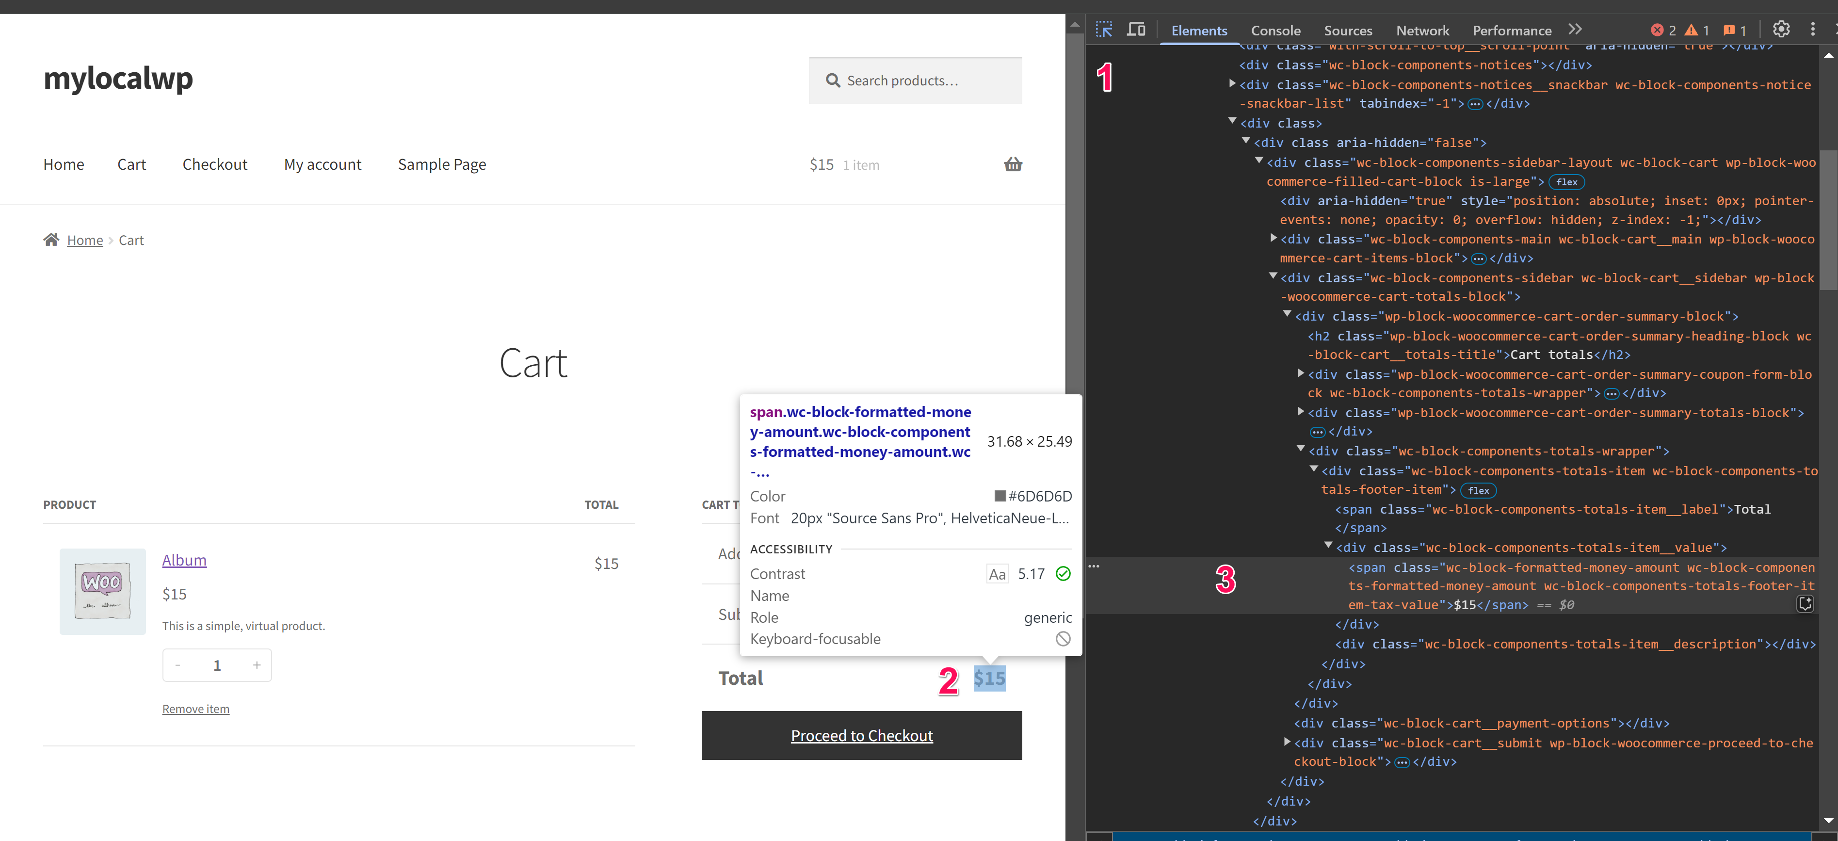
4. **Copy the CSS Selector:**  
   Right-click the highlighted HTML element in the Elements panel. In the context menu, hover over **Copy** and then click on **Copy selector**.  
     
   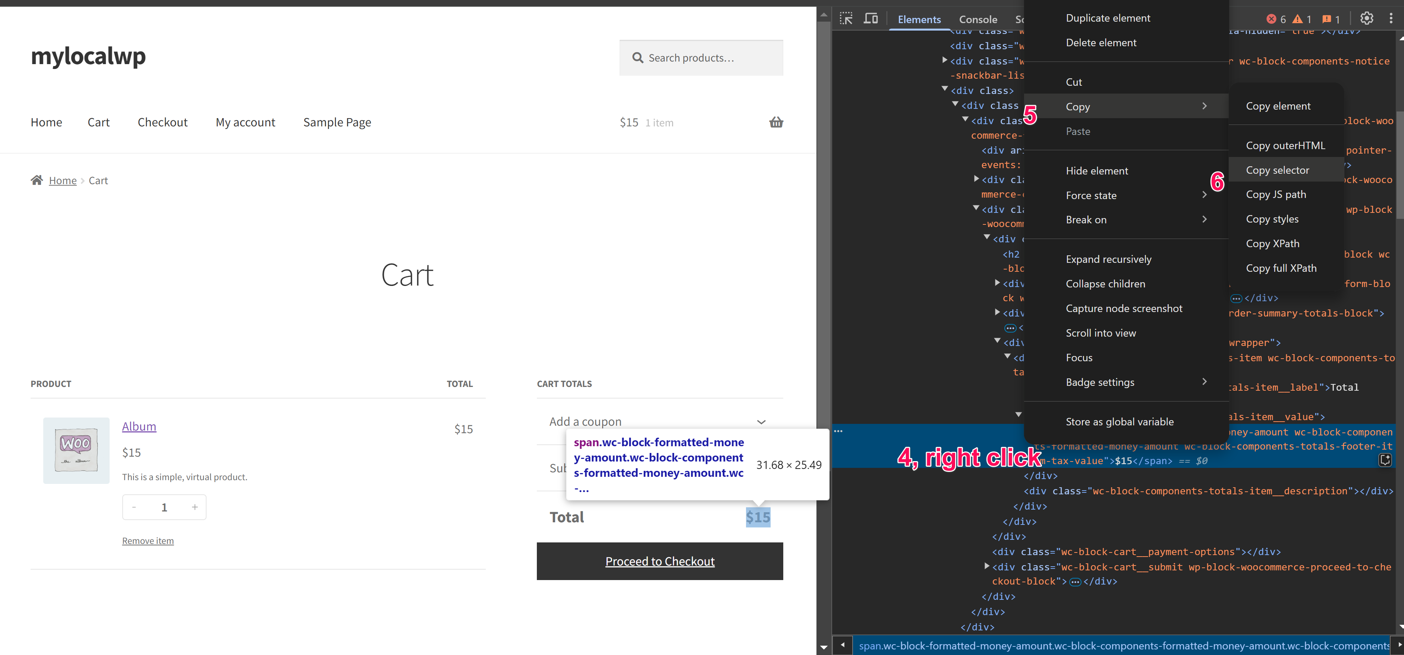
5. **Use the CSS Locator:**  
   The CSS selector is now copied to your clipboard. You can paste it into your code editor, testing script, or wherever you need it.

This process generates a CSS locator that can be used, for example, in automated testing or to apply specific styles via JavaScript or CSS.